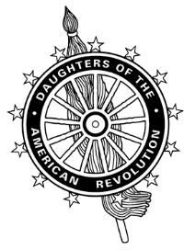
New York State Organization
National Society Daughters of the American Revolution

State Fundraising Policies
In the Standing Rules of the National Society of the Daughters of the American Revolution, General Rule 3 states:
DAR Projects or funds. All fundraising, including through the use of social media and other electronic sales platforms, must comply with federal, state and local regulations concerning sales and solicitations by charitable organizations. Chapters shall abide by the policies set forth by state DAR societies and organizations.
On March 7, 2020, the State Board of Management of the New York State Organization, NSDAR unanimously approved the following policies regarding fundraising by chapters, state committees, and state clubs:
- Chapters of the New York State Organization, NSDAR are restricted from conducting any product or voice sales or fundraising campaigns for their chapter at the state level and outside of their districts. This includes in-person fundraising at outside chapter and state events as well as posts on NYSDAR sponsored social media. Round Tables and Councils may regulate fundraising conducted by chapters at events within their districts.
- State Chairs and State Clubs are required to obtain the State Regent's permission to conduct fundraising at State Conference and the NYS Washington Event. All proceeds must benefit the work of the committee, club, or the State Regent's Project.
Chapters may continue to hold fundraising events and benefits that are open to outside members.

